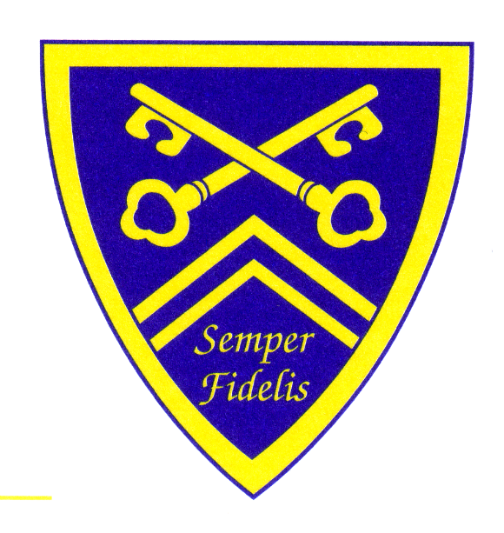

HAGLEY CATHOLIC HIGH SCHOOL

**TRANSPORT**

**INFORMATION**

**2020/2021**

**TRANSPORT INFORMATION BY TRAIN**

**Travelling by Train**

If you live near a station on the Birmingham to Worcester line, you can apply via West Midlands Trains for a **Scholars’ Train Pass,** which is cheaper than passes available to purchase at the stations.

The offer is now entirely self-serve and can be redeemed via [www.wmr.uk/students](http://www.wmr.uk/students) – you simply need to select your destination and origin stations, and the discount is automatically calculated as part of the price. Passes are then posted out directly to you.

Any queries on tickets, orders, or replacements contact  [businesstravel@greateranglia.co.uk](mailto:businesstravel@greateranglia.co.uk), the sister company fulfilling tickets.

If a student leaves any belongings on the train then you should ring West Midlands Trains Customer Service Department on 0121 634 2040. You will need to provide details of which train they were on and a description of the items left.

**Parents of pupils living in Staffordshire should ring 0300 111 8000 for advice on transport assistance.**

**Please note that Birmingham and Sandwell councils do not provide transport assistance to Hagley Catholic High School pupils.**

**Parents of pupils residing within Dudley MBC can apply for transport assistance if they are entitled to free school meals or they are receiving maximum working tax credits and Hagley Catholic High School is their nearest Catholic school. Applications for train passes in these circumstances should be made via Dudley MBC, telephone 0300 555 2345.**

**Any other transport queries – Please contact Mrs S Tyrrell on 01562 883193.**

**TRANSPORT INFORMATION BY BUS  
  
Travelling by Bus from Stourport, Bewdley & Kidderminster direction.**

The council no longer provide a direct service to the school.

The options available are the public buses:

From Stourport numbers 3, 295 or 294

Bewdley numbers 2, 2L,291,125

**Worcestershire parents entitled to free school meals or receiving maximum working tax credit should enquire about transport assistance at** [**www.worcestershire.gov.uk**](http://www.worcestershire.gov.uk) **or call the Worcestershire Hub on 01905 765765.**

**Travelling by Bus for non-Worcestershire residents**

**Evergreen Coaches Ltd (Thandi),** currentlyoperates these routes. Please see the timetables on page 3.

The annual fare for 2020/ 2021 has been confirmed as £695 payable in one payment or Direct Debit over 10 months.

The application form is attached **Appendix A**

**Parents of pupils living in Staffordshire should ring 0300 111 8000 for advice on transport assistance.**

**Please note that Birmingham and Sandwell councils do not provide transport assistance to Hagley Catholic High School pupils.**

**Parents of pupils residing within Dudley MBC can apply for transport assistance if they are entitled to free school meals or they are receiving maximum working tax credits and Hagley Catholic High School is their nearest Catholic school. Applications for bus passes in these circumstances should be made via Dudley MBC, telephone 0300 555 2345.**

**Any other transport queries – Please contact Mrs S Tyrrell on 01562 883193.**

**NON WORCESTERSHIRE RESIDENTS**

**BUS TIMETABLES**

**SERVICE HC1**

|  |  |  |
| --- | --- | --- |
| **Pick Up Point** | **Morning pick-up** | **Afternoon return** |
| Hagley Road West | 07.50 | 16.25 |
| West Boulevard | 08.10 | 16.19 |
| Hagley Road West | 08.15 | 16.05 |
| Hagley Road | 08.23 | 15.55 |
| Hagley Catholic High School | 08.35 | 15.45 |

**SERVICE HC2**

|  |  |  |
| --- | --- | --- |
| **Pick Up Point** | **Morning pick-up** | **Afternoon return** |
| City Road | 07.46 | 16.27 |
| Hagley Road West (Kingshead) | 07.50 | 16.21 |
| Hagley Road West (Toby Carvery) | 07.55 | 16.16 |
| Manor Lane (Royal Oak) | 08.03 | 16.11 |
| Halesowen Bus Station | 08.10 | 16.03 |
| Hagley Road (Fox Hunt) | 08.17 | 15.56 |
| Hagley Catholic High School | 08.30 | 15.45 |

**SERVICE HC3**

|  |  |  |
| --- | --- | --- |
| **Pick Up Point** | **Morning pick-up** | **Afternoon return** |
| Lordswood Road | 07.46 | 16.26 |
| Genners Lane | 08.00 | 16.13 |
| Manor Lane | 08.08 | 16.04 |
| Hagley Road | 08.15 | 15.55 |
| Hagley Catholic High School | 08.23 | 15.45 |

**SERVICE HC4**

|  |  |  |
| --- | --- | --- |
| **Pick Up Point** | **Morning pick-up** | **Afternoon return** |
| Stoney Lane | 07.43 | 16.29 |
| Thimblemill Road | 07.49 | 16.23 |
| Tame Road | 08.00 | 16.13 |
| Quinton by Stag and Three Shoes Pub | 08.05 | 16.01 |
| Hagley Road | 08.15 | 15.56 |
| Hagley Catholic High School | 08.27 | 15.45 |

The times shown above are the main timing points, but the buses do stop at other recognised bus stops along each route.



**Ordering Scholars Train Passes**

**(Should be available to order from 1st August)**

1. Click on this link [www.wmr.uk/students](http://www.wmr.uk/students) or copy it into your browser.
2. On the page, that appears click on Buy Tickets.

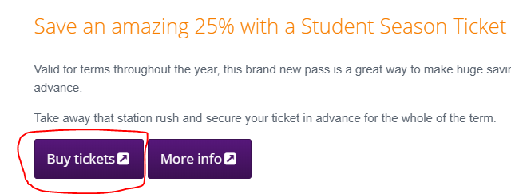

1. On the next page that appears select 24 per page

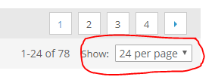

1. Then scroll down the page to the bottom where you will see Hagley Full Term or Hagley Short Term Season Ticket

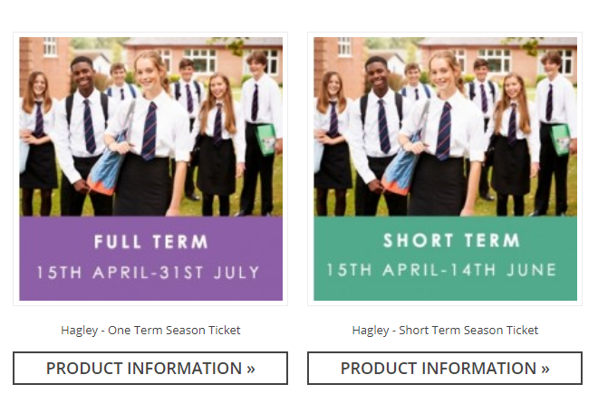

1. Select the pass you wish to order and click on the picture.
2. Scroll down the page to where it says Choose Ticket.

In Status Select age of student

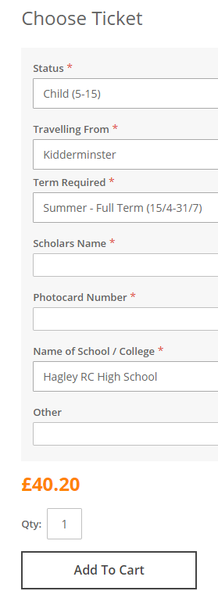

Insert the students first name and last name

Once complete click on Add to Cart

Other can be left blank

Select Hagley RC High School

Insert the photocard number or ‘***New’

Select, which pass you would like

Select the station they travel from

1. Then click on Proceed to Checkout
2. The first time you order a pass you will need to Create an Account so click on Register
3. Complete the information that you are asked for.
4. Select the postal option you would like to use
5. Insert the payment details
6. Review your order and submit it
7. Your pass will be sent to the address you put into Billing Information